Customer Shopping Behavior
Analysis
Understanding customer decisions through data and insights

Tools Used:
Python (pandas, matplotlib) · Power BI

TABLE OF CONTENT

Chapter 1: Introduction ..................................................... 1
1.1 Problem Statement .............................................. 1
1.2 Motivation .......................................................... 1
1.3 Objectives ........................................................... 1
1.4 Scope of the Project ............................................. 2
Chapter 2: Project Overview ............................................. 3
2.1 Overview of Customer Behavior Analysis ............ 3
2.2 Dataset Summary ................................................ 3
Chapter 3: Methodology .................................................... 4
3.1 Data Cleaning & Preprocessing ......................... 4
3.2 Feature Engineering .......................................... 5
3.3 Data Consistency Checks ................................ 6
Chapter 4: Data Analysis .................................................. 7
4.1 Revenue Analysis .............................................. 7
4.2 Product Rating Analysis ................................... 7-8
4.3 Shipping Type Analysis .................................... 8
4.4 Discount Analysis ............................................ 8-9
4.5 Customer Segmentation ................................. 9
4.6 Age Group Analysis .......................................... 10
Chapter 5: Dashboard Visualization ............................. 11
Chapter 6: Business Recommendations ..................... 12
Chapter 7: Conclusion ..................................................... 13
7.1 Key Findings ...................................................... 13
7.2 Limitations .......................................................... 13
7.3 Future Scope .................................................... 13
References ...................................................................... 14

CHAPTER 1

Introduction
In today’s retail industry, understanding customer behavior is essential for improving sales and customer satisfaction. Businesses collect large amounts of data, but meaningful insights can only be obtained through proper analysis.
This project focuses on analyzing customer shopping behavior using transactional data. It examines factors such as demographics, product categories, purchase amounts, and discounts to identify patterns and trends.
Using Python for data analysis and Power BI for visualization, the project provides insights into customer preferences and purchasing behavior. These insights help businesses make better decisions and improve their marketing strategies.

1.1 Problem statement
A leading retail company wants to better understand its customers’ shopping behavior in order to improve sales, customer satisfaction, and long-term loyalty. The management team has noticed changes in purchasing patterns across demographics, product categories, and sales channels (online vs. offline). They are particularly interested in uncovering which factors, such as discounts, reviews, seasons, or payment preferences, drive consumer decisions and repeat purchases.

1.2 Motivation
The motivation for this project comes from the growing importance of data-driven decision-making in the retail industry. Businesses generate large volumes of customer data, but often fail to utilize it effectively to understand purchasing behavior and improve performance.
Analyzing customer shopping behavior helps identify trends, preferences, and factors that influence buying decisions. This can lead to better marketing strategies, improved customer satisfaction, and increased revenue.
This project aims to apply data analytics techniques to transform raw customer data into meaningful insights, demonstrating how businesses can make smarter and more informed decisions.

Objectives
- To analyze customer shopping behavior using transactional data
- To identify patterns in purchasing across demographics and product categories
- To evaluate the impact of factors such as discounts, ratings, and shipping type on sales
- To segment customers into groups based on purchase history
- To visualize insights using tools like Python and Power BI for better interpretation

Scope of the Project
This project focuses on analyzing a retail customer dataset to understand shopping behavior and identify key trends. The analysis is limited to exploratory data analysis and basic customer segmentation using Python.

It includes studying factors such as customer demographics, product preferences, purchase amount, discounts, and seasonal trends. The results are visualized through a Power BI dashboard to support better decision-making.

The project does not include advanced predictive modeling or real-time data processing and is limited to the available dataset.

CHAPTER 2

Project overview
This project analyzes customer shopping behavior using transactional data from 3,900 purchases across various product categories. The goal is to uncover insights into spending patterns, customer segments, product preferences, and subscription behavior to guide strategic business decisions.
2.1 Overview of Customer Behavior Analysis
Customer behavior analysis is the process of studying how customers make purchasing decisions and interact with products. It involves analyzing data such as purchase frequency, spending patterns, and product preferences to identify trends.
In the retail industry, understanding customer behavior helps businesses improve marketing strategies, increase customer satisfaction, and boost revenue. It allows companies to identify key factors that influence buying decisions, such as discounts, product ratings, and seasonal demand.
In this project, customer behavior analysis is performed using transactional data to uncover patterns and support data-driven decision-making.

2.2 Dataset Summary
- Rows: 3,900 - Columns: 18 - Key Features:
- Customer demographics (Age, Gender, Location, Subscription Status)
- Purchase details (Item Purchased, Category, Purchase Amount, Season, Size, Color)
- Shopping behavior (Discount Applied, Promo Code Used, Previous Purchases, Frequency of
Purchases, Review Rating, Shipping Type)
- Missing Data: 37 values in Review Rating column

CHAPTER 3

Methodology
This chapter describes the steps followed to prepare and analyze the dataset. It includes data cleaning, feature engineering, and consistency checks to ensure accurate and reliable analysis.

3.1 Data Cleaning & Preprocessing
We began with data preparation and cleaning in Python:
- Data Loading: Imported the dataset using pandas.
Initial Exploration: Used df.info() to check structure and .describe() for summary statistics. 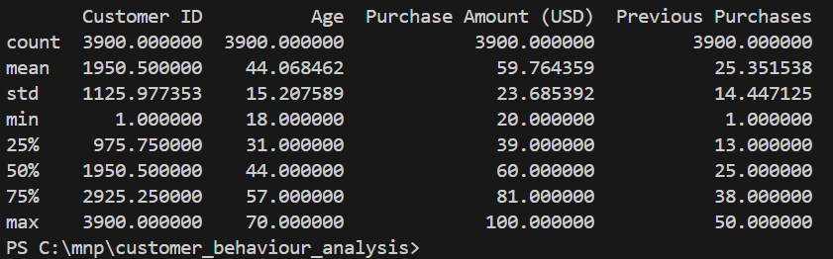
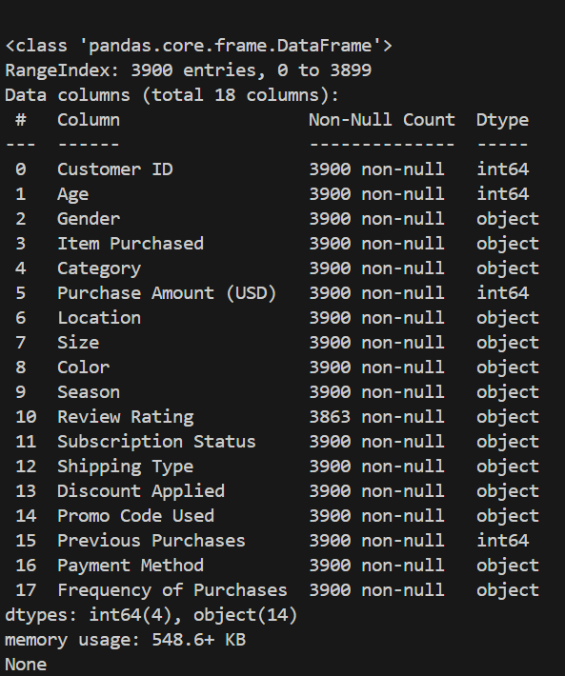
- Missing Data Handling: instead of replacing null column with mean over mean we imputed the mean for the product with respected product category which eliminates the bad influence of mean on the products

- Column Standardization: Renamed columns to snake case for better readability and documentation.

3.2 Feature Engineering

Feature engineering was performed to create new meaningful variables from existing data.
- Age Group Creation: Customers were grouped into categories (Young Adults, Adults, Middle-aged, Senior) using binning techniques to simplify demographic analysis.
- Purchase Frequency Conversion: The categorical variable frequency_of_purchases was converted into numerical values (in days) using a mapping approach. This enabled easier comparison and analysis of customer behavior.

3.3 Data Consistency Checks
Data consistency checks were conducted to ensure the reliability of the dataset.
- The columns discount_applied and promo_code_used were compared and found to contain similar information. Therefore, the promo_code_used column was removed to avoid redundancy.
- The dataset was checked for duplicate values and inconsistencies to ensure data quality.
- Final verification was performed to confirm that all transformations and preprocessing steps were correctly applied before analysis.

CHAPTER 4

Data Analysis using pandas and matplolib
We performed structured analysis in in vs-code using pandas and matplotlib to answer key business questions as followed:
  - .Revenue by Gender – Compared total revenue generated by male vs. female customers. 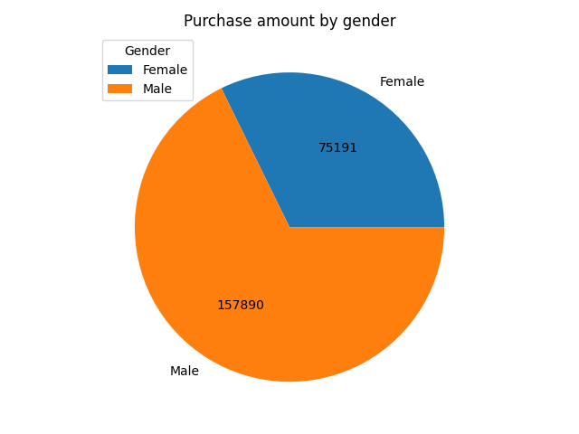

  - . Top 5 Products by Rating – Found products with the highest average review ratings.

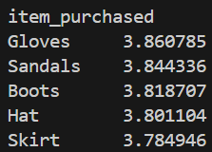
  - Shipping Type Comparison – Compared average purchase amounts between Standard and Express shipping.
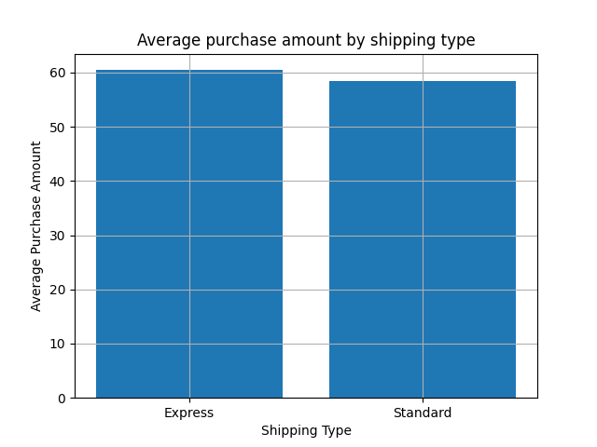

  - . Discount-Dependent Products – Identified 5 products with the highest percentage of discounted purchases.

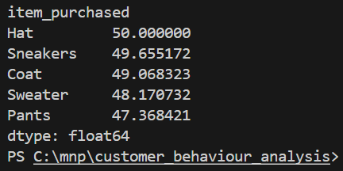

  - Customer Segmentation – Classified customers into New, Returning, and Loyal segments based on purchase history.

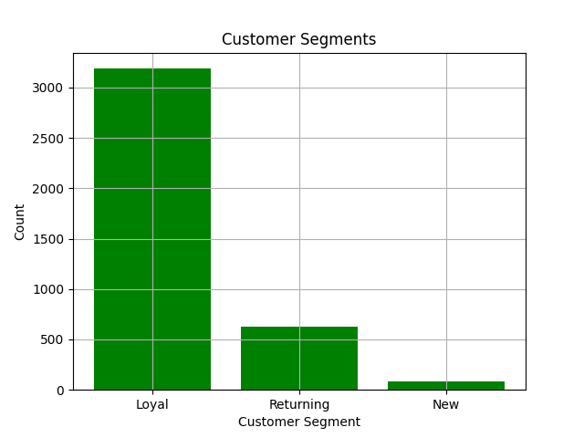

  - Revenue by Age Group – Calculated total revenue contribution of each age group.

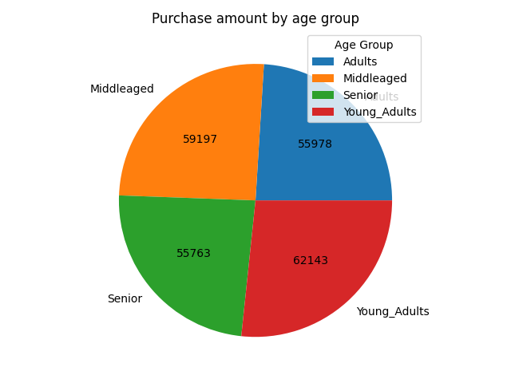

CHAPTER 5

Dashboard in Power BI

An interactive dashboard was developed using Power BI to visualize customer shopping behavior and key performance metrics. The dashboard provides an overview of total transactions, average purchase value, and average customer rating.
It includes visualizations such as revenue by product category, sales distribution across age groups, seasonal trends, and product-wise review ratings. Filters (slicers) are provided for subscription status, gender, product category, and shipping type, allowing users to dynamically explore the data.
The dashboard enables quick identification of high-performing categories, customer segments, and trends, making it easier to derive meaningful business insights and support decision-making.

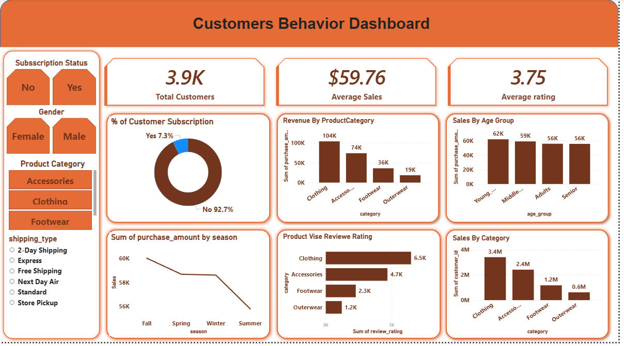

CHAPTER 6

Business Recommendations
1. Improve Gender-Based Market Balance
Male customers contribute significantly higher revenue (157,890) compared to female customers (75,191). Targeted marketing and personalized recommendations should be used to increase engagement from female customers

2. Focus on High-Revenue Products
Products like Hat, Sneakers, Coat, and Sweater generate higher purchase value, while items like Gloves and Sandals are frequently bought but lower in value. The business should promote high-value products through upselling and bundling strategies.

3. Optimize Shipping as a Support Feature
The difference in average purchase between Express and Standard shipping is minimal. Shipping strategies should focus on customer convenience (e.g., free shipping offers) rather than revenue growth.

4. Strengthen Customer Acquisition
The number of loyal customers is high, but new customers are very low. The business should invest in acquiring new customers through campaigns, referrals, and introductory offers.

5. Improve Customer Conversion
There is a gap between new, returning, and loyal customers. Strategies should focus on converting new customers into repeat buyers through better engagement and incentives.

- Target High-Contributing Age Groups-
Young and middle-aged customers contribute the most to sales, making them ideal targets for personalized marketing campaigns.

CHAPTER 7

7.1 Key Findings
The analysis of customer shopping behavior revealed several important insights. The Clothing category was identified as the highest revenue-generating segment, indicating its significance in overall sales. Young and middle-aged customers contribute the largest share of revenue, making them key target groups for marketing strategies.
It was observed that only a small percentage of customers (~7%) have subscribed, indicating a strong opportunity for improving subscription conversion. Discounts were found to influence purchasing behavior for certain products, highlighting customer price sensitivity.
Additionally, seasonal trends showed variation in sales across different seasons, and customers using express shipping tend to have slightly higher purchase amounts. These findings provide valuable insights for improving customer engagement and business performance.

7.2 Limitations
The analysis is based on a limited dataset and may not represent real-world scenarios completely.
Customer segmentation is based on simple rules and may not capture complex behavior patterns.
The study focuses only on historical data and does not include real-time analysis.
External factors such as market trends and competition are not considered.
7.3 Future Scope
Implement advanced techniques such as machine learning for customer prediction and segmentation.
Perform real-time data analysis for dynamic decision-making.
Develop recommendation systems to suggest products to customers.
Expand the dataset to include more features such as customer feedback and browsing behavior.

7.4 reference :
Pandas Documentation: https://pandas.pydata.org/
Matplotlib Documentation: https://matplotlib.org/
Power BI Documentation: https://learn.microsoft.com/en-us/power-bi/
Dataset: https://github.com/amlanmohanty1/customer-trends-data-analysis-SQL-Python-PowerBI/blob/main/customer_shopping_behavior.csv

